SACRED HEART CHURCH WIMBLEDON
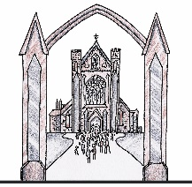

BAPTISM APPLICATION FORM
(Print clearly. Detach this side and hand it in.)

Surname of Child
All first names
Date of birth
Father’s full name
Religion (be precise; do not put ‘Christian’)
Mother’s full name
Maiden name
Religion (be precise; do not put ‘Christian’)
Address

Telephone no
Email
(Please print clearly)
Preferred dates (Sundays)
(Please give more than one if possible)

Godparent 1

Name ……………………………………………………………..

Date and place of Baptism ………………………………………………….

Date and place of confirmation …………………………………………….

Godparent 2

Name ……………………………………………………………..

Date and place of Baptism ………………………………………………….

Date and place of Confirmation …………………………………………...

Please read: “I consent to the parish keeping this sheet secure and storing this information in electronic form on a secure computer for use solely by members of the parish team on parish business, and understand that, apart from the official written record in the Church Baptism Register, this data will be deleted at my request “.

Signed Date ______________

