Bible Study This Lent
Sacred Heart Church
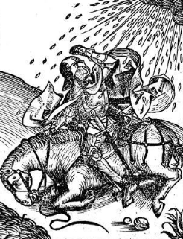
With Fr Peter Edmonds SJ
Biblical Scholar
Preparing for Easter With Paul- Glimpses of an Apostle
Every Thursday during lent at 7:30 in the Upper Hall Thursdays: 7th, 14th , 21st. 28th March and 4th April
Each session is expected to end at 8:30, but afterwards there will be scope for small group for small group spiritual formation for those who express an interest

